Click
First Authorª, Second Author^{b}, Third Author^{a,b,*}
ªFirst affiliation, Address, City and Postcode, Country
^{b}Second affiliation, Address, City and Postcode, Country
Article history:
Received: xx xxxx xxxx / Received in revised form: xx xxxx xxxx / Accepted: xx xxxx xxxx (to be inserted by publisher)

Abstract
This is a guideline for preparing papers for Communications in Humanity and Social Science in Microsoft Word. Please do not alter the formatting and style layout as well as font sizes given in this template. In the author field, full names of author are preferred, but not required. The abstract should briefly state the problem or purpose of the research, indicate the methodology used, summarize the principal findings and major conclusions. This should be no more than 150 words. All symbols used should be clearly defined and references are not cited here. The names of heading in this template can be modified if necessary, except the Introduction.
Keywords: Provide 2-5 keywords here (separated by semicolons ;). These are intended to aid the reader in literature retrieval.

- Introduction
(10 pt) Start your main text with Introduction. It should provide the background of the research and state the purpose of the research. The authors allow readers outside of the field to understand the purpose of the study. The introduction should include appropriate citations of previous and relevant works. This should be no more than 650 words.
The paragraphs could continue from here. Please make sure that you use as much as possible normal fonts in your text. Special fonts, such as fonts used in the Far East (Japanese, Chinese, Korean, etc.) may cause problems during processing. To avoid unnecessary errors, you are strongly advised to use the ‘spellchecker’ function of MS Word.
- Methodology
Describe the methodology and methods you use in your research here. Remember that replication is required for scientific progress, so your description must provide sufficient information to allow readers to perform similar experiments or calculations.
  - Subheading
Paragraphs could be separated by headings, subheadings, images and formulae. Section headings should be left justified, with the first letter capitalized and numbered consecutively. The section headings are arranged by numbers, bold and 10 pt. Sub-section headings should be in capital and lower-case italic letters, numbered 2.1, 2.2, etc, and left justified, with second and subsequent lines indented.
  - Equations
Number equations consecutively with Arabic numerals in parentheses. Equation numbers are on the right hand side of the page (if referred to explicitly in the text) using a right tab stop. Note that the equation is centered using a center tab stop. Be sure that the symbols in your equation have been defined before or immediately following the equation. See Eq. (1) for example.
y = α x + β (1)
They should also be separated from the surrounding text by one space. Use “(1)”, not “Eq. (1)” or “equation (1)”, except at the beginning of a sentence: “Equation (1) is . . .”
- Results and Discussion
Present and elaborate your research results here. Although not everything need be disclosed, a good paper must contain new, useable, and fully described information. Authors should expect to be challenged by reviewers if the results are not supported by adequate data and critical details.
  - Tables
All tables should be numbered with Arabic numerals. Headings should be placed above tables, centered. Only horizontal lines should be used within a table, to distinguish the column headings from the body of the table, and immediately above and below the table. Tables must be embedded into the text and not supplied separately. Tables could fit in 8.5 cm (1 column) or 17.5 cm (2 columns). Table 1 is an example which may be useful. Large tables may span across both columns.
* Corresponding author. Tel.: +0-000-000-0000; fax: +0-000-000-0000.
Email: author@institute.xxx.
Table 1. An example of a table
Heading 1 | Heading 2 | Heading 3
Item a | 0.01 | 0.20
Item b | 0.56 | 0.34
Item c | 0.67 | 0.78
  - Figures
All figures, including photographs, schemas, graphs, charts and diagrams, should be numbered with Arabic numerals (1, 2, ... n). Authors are required to ensure that all figures are in good quality and acceptable resolution. Figures must be embedded into the text and not supplied separately. Lettering and symbols should be clearly defined either in the caption or in a legend provided as part of the figure. Figures should be as close as possible to the first reference to them in the paper. The figure number and caption should be typed below the illustration in 9pt and centered. Figures could fit in 8.5 cm (1 column) or 17.5 cm (2 columns). Fig. 1 gives an example. Large figures may span across both columns

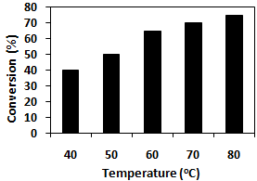
Fig. 1. Example of figure
  - Multipart Figures
If you have two or more sub-images in a figure, these may be placed side-by-side, if possible, to save space. Otherwise, they can be stacked. See Fig. 2 for example.
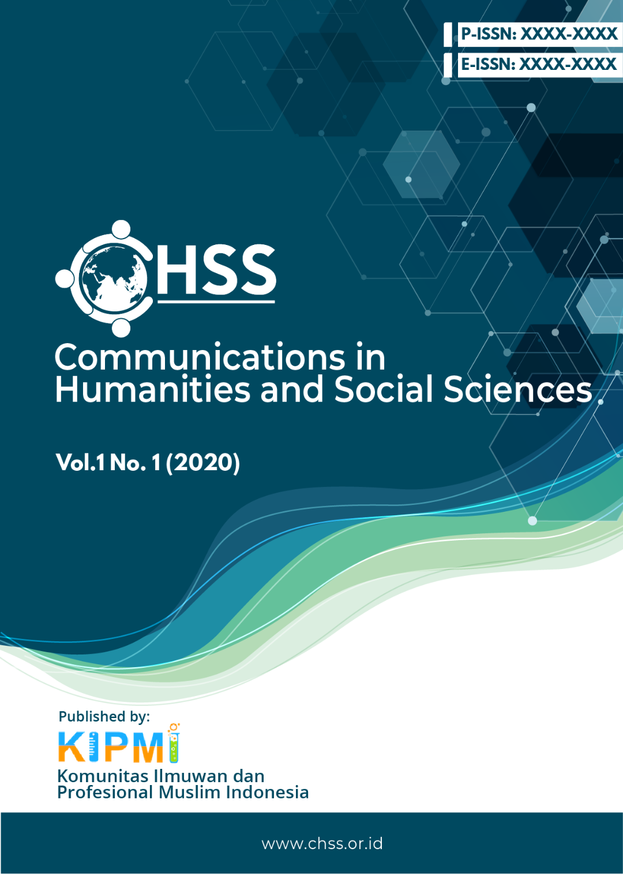

(a)
(b)

Fig. 2. Example for figure with two sub-figures: (a) first -sub-figure; (b) second sub-figure

- Conclusion
The conclusion is placed here. A conclusion reviews the main points of the paper, do not replicate the abstract as the conclusion. A conclusion might elaborate on the importance of the work or suggest applications and extensions.
Acknowledgements
Acknowledgement and the Reference headings are in bold but without numbering. Type your acknowledgement here if you have one. Otherwise, delete it.
References
References and citations should be prepared in the APA 6 (http://owl.english.purdue.edu/owl/resource/560/02/) format. References have to be cited in article text. Below are some examples.

Angeli, E., Wagner, J., Lawrick, E., Moore, K., Anderson, M., Soderland, L., & Brizee, A. (2010, May 5). General format. Retrieved from http://owl.english.purdue.edu/owl/resource/560/01/
Calfee, R. C., & Valencia, R. R. (1991). APA guide to preparing manuscripts for journal publication. Washington, DC: American Psychological Association.
Duncan, G. J., & Brooks-Gunn, J. (Eds.). (1997). Consequences of growing up poor. New York, NY: Russell Sage Foundation.
Harlow, H. F. (1983). Fundamentals for preparing psychology journal articles. Journal of Comparative and Physiological Psychology, 55, 893-896.
Helfer, M. E., Kempe, R. S., & Krugman, R. D. (1997). The battered child (5th ed.). Chicago, IL: University of Chicago Press.
Henry, W. A., III. (1990, April 9). Making the grade in today's schools. Time, 135, 28-31.
Lastname, F. N. (Year). Title of dissertation. (Doctoral dissertation). Retrieved from Name of database. (Accession or Order Number)
Lastname, F. N. (Year). Title of dissertation. (Unpublished doctoral dissertation). Name of Institution, Location.
O'Neil, J. M., & Egan, J. (1992). Men's and women's gender role journeys: A metaphor for healing, transition, and transformation. In B. R. Wainrib (Ed.), Gender issues across the life cycle (pp. 107-123). New York, NY: Springer.
Plath, S. (2000). The unabridged journals. K. V. Kukil (Ed.). New York, NY: Anchor.
Schnase, J. L., & Cunnius, E. L. (Eds.). (1995). Proceedings from CSCL '95: The First International Conference on Computer Support for Collaborative Learning. Mahwah, NJ: Erlbaum.
Schultz, S. (2005, December 28). Calls made to strengthen state energy policies. The Country Today, pp. 1A, 2A.
Scruton, R. (1996). The eclipse of listening. The New Criterion, 15(30), 5-13.

